Power Shell 101
Module 3 Hands-on Activity – PowerShell in VSCode
4/20/2019 Developed by Sion Yoon
4/20/2019 Tested by Sam Chung
Center for Information Assurance (CIAE) at City University of Seattle

Learning Outcomes
- Learn about cmdlet, alias, and PSDrives in PowerShell.
- Learn how to map a new PSDrive

Resources
- Cmdlet Overview
https://docs.microsoft.com/en-us/powershell/developer/cmdlet/cmdlet-overview
- About Providers
https://docs.microsoft.com/en-us/powershell/module/microsoft.powershell.core/about/about_providers?view=powershell-6
- https://www.youtube.com/watch?v=_AiTBoH4IwA

Activities
- Using cmdlet
- Using alias
- Mapping PSDrives
- Q&A

Cmdlet
- Open PowerShell in VSCode

- Cmdlets are lightweight PowerShell scripts that perform a single function. PowerShell uses a verb-noun name pair to name cmdlets. For example, type “get-location”
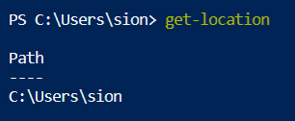

- “get-help” can be used to learn more about the command. To learn about the get-location cmdlet, type “get-help get-location” or “help get-location”.
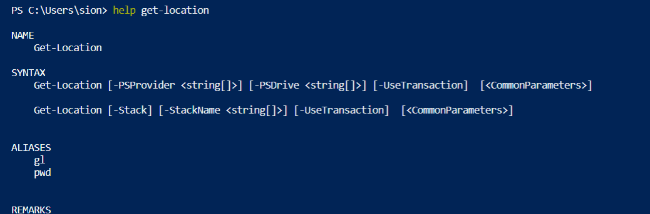

Alias
- Alias are shortcuts or alternate names for cmdlets. Use aliases when you do not want to type the verb-noun format. To get a list of aliases, type “get-alias” or “gal”. Notice that many UNIX commands (“ls”, “cd”, etc.) are set up as aliases by default.
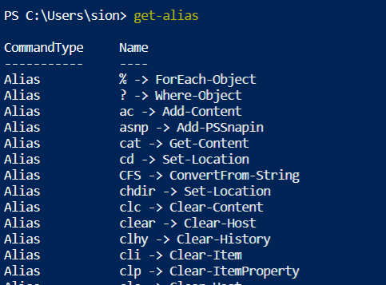

- To get a list of aliases that start with the letter c, type “gal c*”
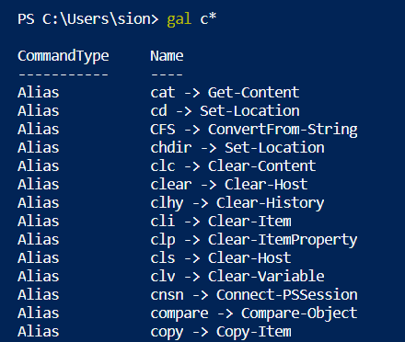

- You can use an alias, and it works the same as the cmdlet that it references. Type “Clear-Host” or “clear” or “cls”.


Mapping PSDrives
- PowerShell providers connect different forms of storage to PowerShell and make the forms of storage look like a file system. The providers provide access to data and components that would not be easily accessible at the command line. Type “get-psdrive” to see the list of providers.
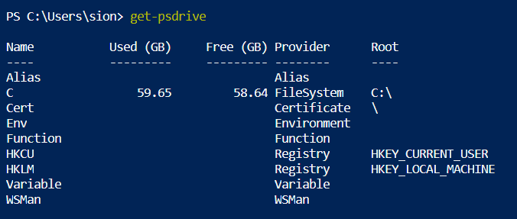

- To map a new drive, let’s start by creating a folder named ‘test’. Type “mkdir test”
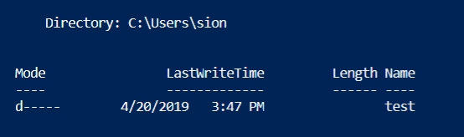

- To learn how to map a new drive, type “help new-psdrive”. 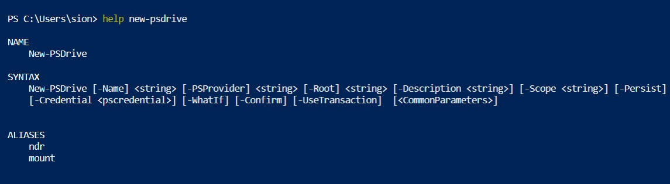

- If you look at the syntax, you will see that you can map a new drive by typing
“new-psdrive test filesystem c:\users\sion\test” for my case.
You will need to input your root path.
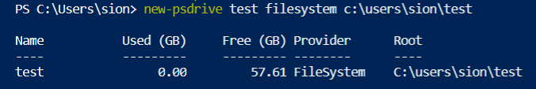
- To go the test drive that you just created, type “cd test:”
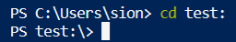
- Let’s go back to the psdrive to check if the new drive is there.
Type, “get-psdrive”.
Remember this is a psdrive and only exist within PowerShell.
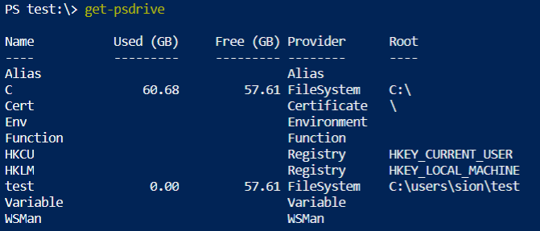

- Now if you go back to the c drive, type “cd c:”
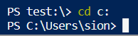

- Let’s now undo what we have done by typing “remove-psdrive test”

- Go back to your psdrive again to check if the drive has been removed
by typing “get-psdrive”
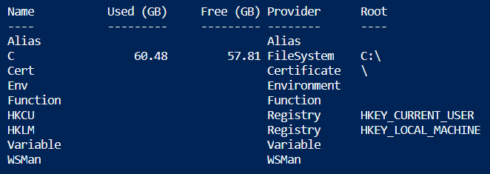

- Remove the test folder by typing “rmdir test”

Q&A
Justify your answers with at least one reference.
- List out five cmdlets that you would use often and describe the function for each cmdlet.
(Answer).
The answer to this question can vary by the student since it listing out the cmdlets that they would use often.
-Get-Help: provides how to use the cmdlet with syntax information.
-Get-Command: allows one to search for certain cmdlets.
-Get-Member: allows one to get information about the objects that a cmdlet returns.
-Where-Object: selects an object based on whether it meets a certain criteria
-Get-Item: allows one to find a particular file or a directory in a particular location

More Cmdlets
-Get-Location: Gets information about the current working location
-Get-History: Gets a list of the commands entered during the current session.
-Find-Package: Finds software packages in available package sources
-Test-WSMan: Tests whether the WinRM service is running on a local or remote computer
-Get-Job: Gets Windows PowerShell background jobs that are running in the current session

- What would happen if you map a new PSDrive just as you have done in our activity and close your PowerShell session? Is the PSDrive persistent or non-persistent?
If non-persistent, what would you do to make it persistent?
(Answer)

PSDrives are non-persistent, and they disappear as soon the session is closed. To have it persistent and make it last even if the session is closed, you can map the PSDrive to the Explorer Window using a switch '-persist' in the New-PSDrive cmdlet. Note that this command only works on folders or drives at a remote location.

Another explanation

From what I found “New-PSDrive” is a temporary and persistent drive so it exists only in the current PowerShell session and in sessions that you create in the current session. To make our driver to not session-specific, we can use “Persist” parameter in PowerShell from 3.0 version. With that parameter, it creates Windows mapped network drives and allows us to access it with standard windows tools such as File Explorer.

https://docs.microsoft.com/en-us/powershell/module/microsoft.powershell.management/new-psdrive?view=powershell-7

